Bray Team

MEEN 401 - 900

10/26/2023

**Lecture 19 TEAM Assignment Embodiment Design**

1. Rule #4 Safety: How do you plan to implement safety using the a) direct approach, b) indirect approach, and/or c) warnings?

* For the direct approach, our team design is going to have a safe-life which will be determined by Bray after they finish running tests in their labs after we find a final product that meets their deliverables. Our design may also incorporate an indirect approach by using protective systems to let workers know if there is a power supply or other related issue.

1. Principle 1 Force and Energy Transmission: Sketch “flowlines of force” in your design. If you feel that this does not apply to your project, explain why.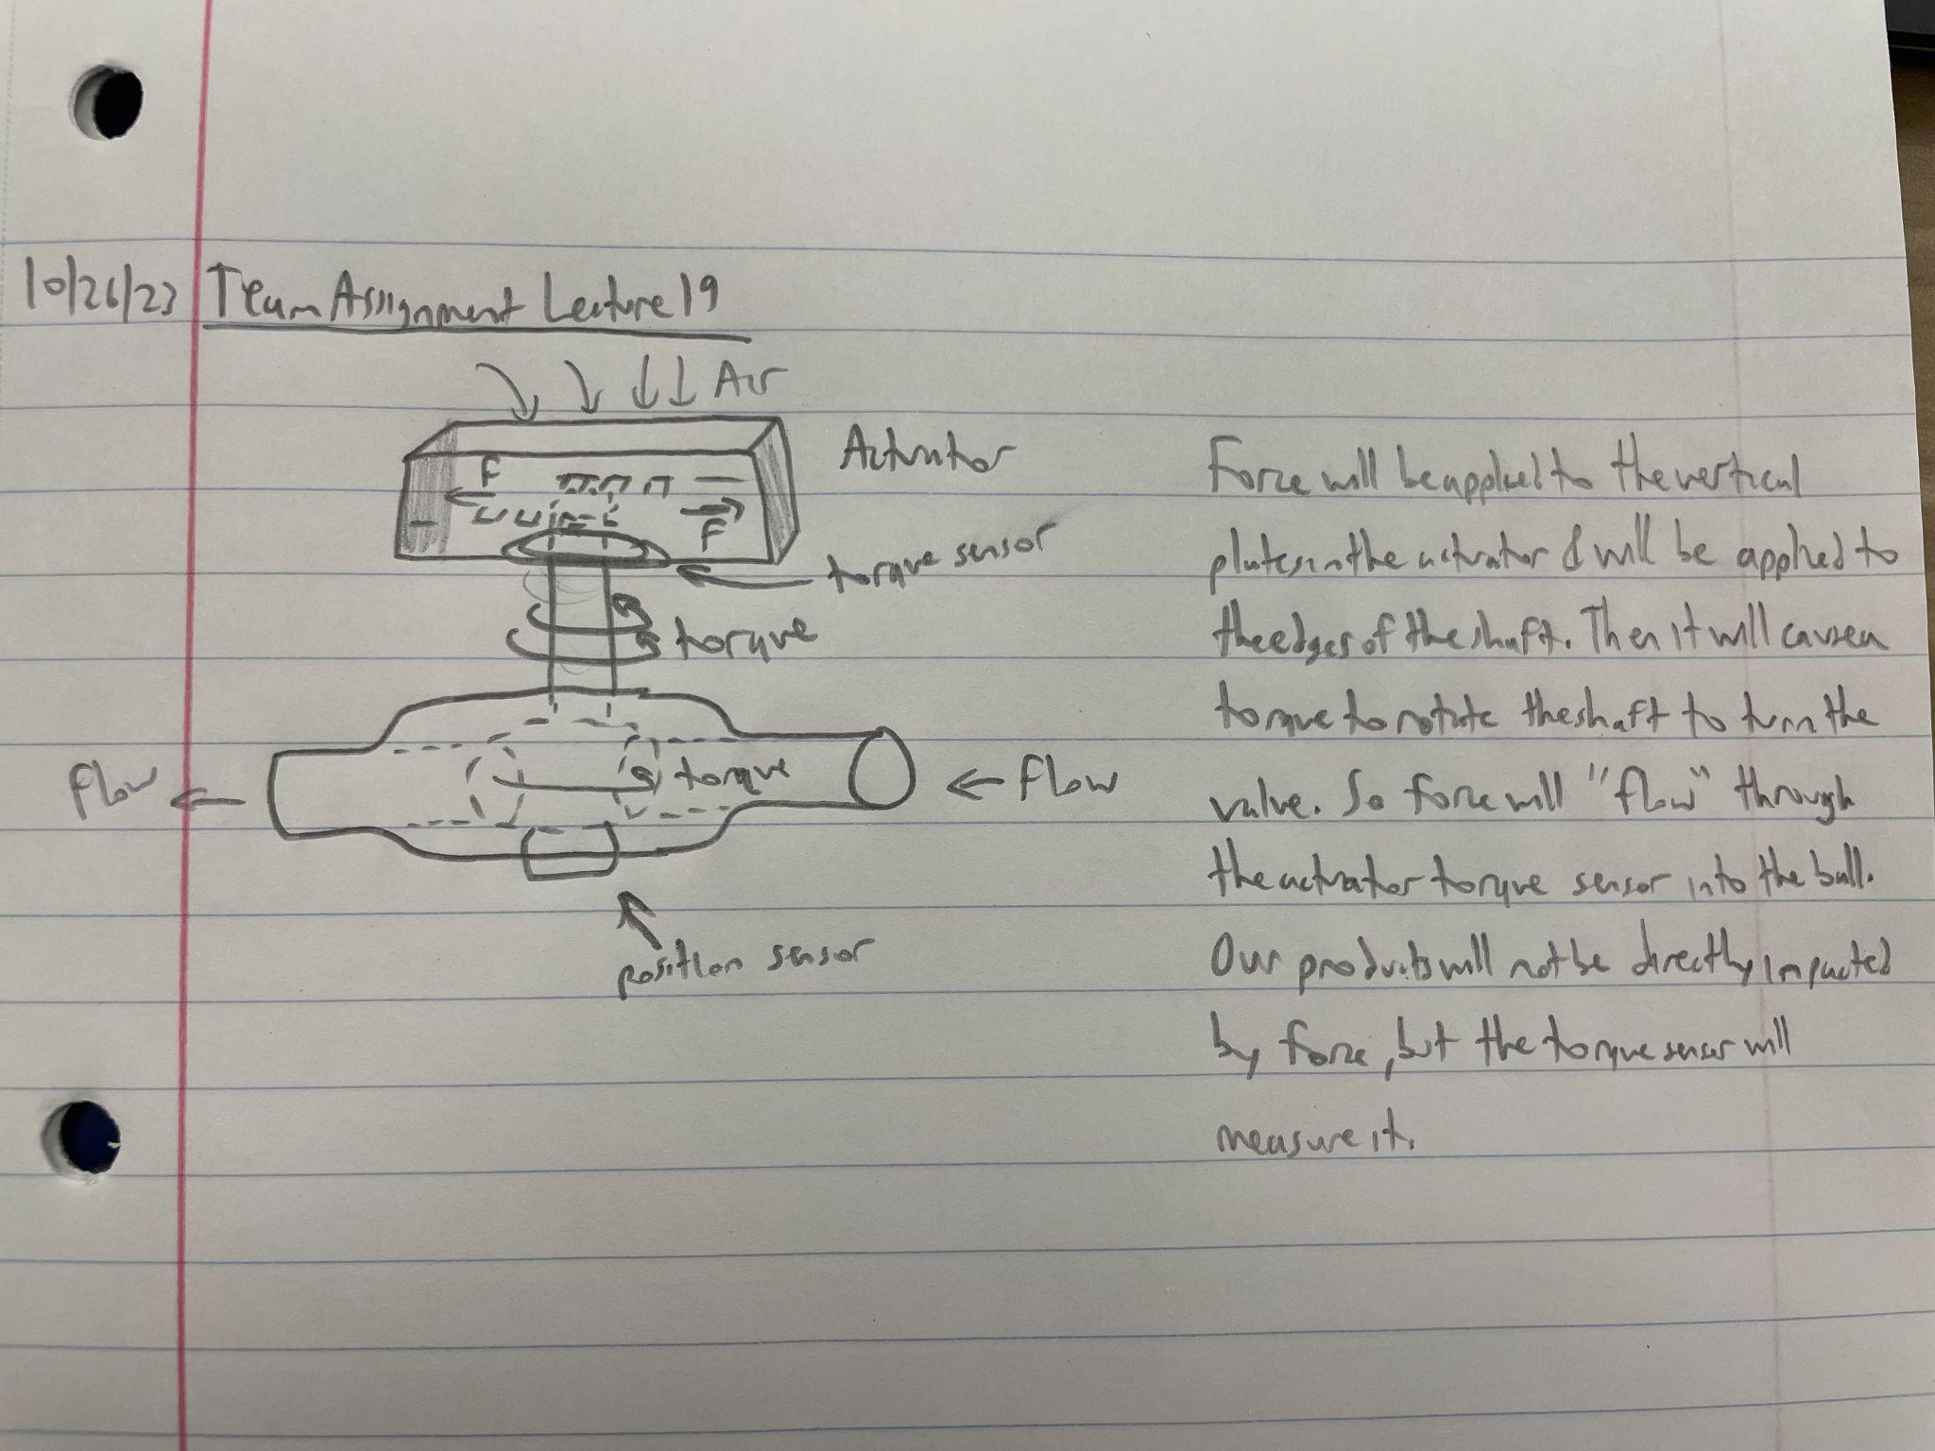
2. Principle 3 Self-Help: Identify at least one way you can utilize the principle of self-help in your system (self-reinforcing, self-balancing, or self-protecting)

* Our data transmission feature will be designed to alert Bray or their customers if the valve begins to open to the wrong position, necessitating preventative maintenance. However, even if the potentiometer goes bad and gives a faulty reading, there will still be a need for maintenance, but on the sensor instead of the valve. In this way, the potentiometer system will alert the company both if the valve goes bad or if the sensing system itself goes bad, and this will perform two functions (both checking the valve health (its main purpose) and the functionality of the sensor (self-protecting).

1. Principle 4 Stability: Identify at least one area in your project where you need to consider the principle of stability?

* Our final products will be able to handle various amounts of torque received from the actuator. Our products must be able to handle dynamic forces and return to their initial state. The ability for the ball of the valve to be closed or open is a form of dual-stability and will avoid low flow rate issues.

1. Guideline #3: What standards and codes must be met for your project?

* The project solutions must meet the US Federal Code for Transportation of Natural and Other Gas by Pipeline, section 49, CFR 192.145. That code sets forth the following requirements:
  + The valve must be of a sound engineering design.
  + Materials subject to the internal pressure of the pipeline system, including welded and flanged ends, must be compatible with the pipe or fittings to which the valve is attached.
  + Each part of the valve that will be in contact with the carbon dioxide or hazardous liquid stream must be made of materials that are compatible with carbon dioxide or each hazardous liquid that it is anticipated will flow through the pipeline system.
  + Each valve must be both hydrostatically shell tested and hydrostatically seat tested without leakage to at least the requirements set forth in section 11 of API Standard 6D (incorporated by reference, see §195.3).

If our design changes the operation or construction of the ball or valve at all, we must ensure that these requirements are still met. Additionally, if our design comes into contact with the fluid through the pipe, it must abide by these requirements as well. These exist in order to ensure that fluids remain safe even when under high temperature, pressure, or other potentially hazardous environmental conditions.